[](http://www.google.com/imgres?q=jack+o+lantern&num=10&hl=en&sa=X&biw=1612&bih=893&tbs=ic:gray&tbm=isch&tbnid=HrI19n22eKUvVM:&imgrefurl=http://www.freeprintable.com/free-printable-coloring-sheets/smiling-jack-o-lantern&docid=WeE2XBHTe5IE_M&imgurl=http://assets.freeprintable.com/images/item/thumb/smiling-jack-o-lantern.jpg&w=200&h=200&ei=U0l_UP2NFuSMyAGStIHQAw&zoom=1&iact=hc&vpx=658&vpy=554&dur=400&hovh=160&hovw=160&tx=126&ty=123&sig=100113455917015609733&page=1&tbnh=140&tbnw=140&start=0&ndsp=44&ved=1t:429,r:9,s:20,i:232) [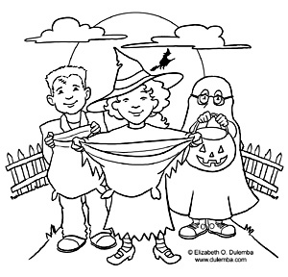](http://www.google.com/imgres?q=cute+trick+or+treaters&hl=en&sa=X&biw=1612&bih=893&tbs=ic:gray&tbm=isch&tbnid=hi6jd0H0AetkRM:&imgrefurl=http://printables.scholastic.com/printables/detail/?id=22242&docid=-kxT9B0b8h9HvM&imgurl=http://content.scholastic.com/content/media/products/18/0439502918_bw211_xlg.jpg&w=224&h=230&ei=DEp_UObYHaS1ygHN7YGIDw&zoom=1&iact=hc&vpx=764&vpy=189&dur=190&hovh=184&hovw=179&tx=115&ty=91&sig=100113455917015609733&page=1&tbnh=140&tbnw=139&start=0&ndsp=40&ved=1t:429,r:3,s:0,i:81)

6th Annual Trunk N’ Treat

Sunday October 29

At the

Cairo United Methodist Church

506 E Kansas St

5:00-7:00 pm

Roasting Hot Dogs outside and

we will have s’mores, face painting & activities!

There will also be a Haunted Hallow put on by our MYF Group.

Bring your kids in their Halloween Costumes for a fun, safe time of Trick or Treating!! We are also asking for you to bring a canned good item for donation to our local food pantry.